ContactManagement_Verify Contact notes _Instance44_13-Jul-2018_06-27-00_AM_VerifyingAllNotesofanindividual.png

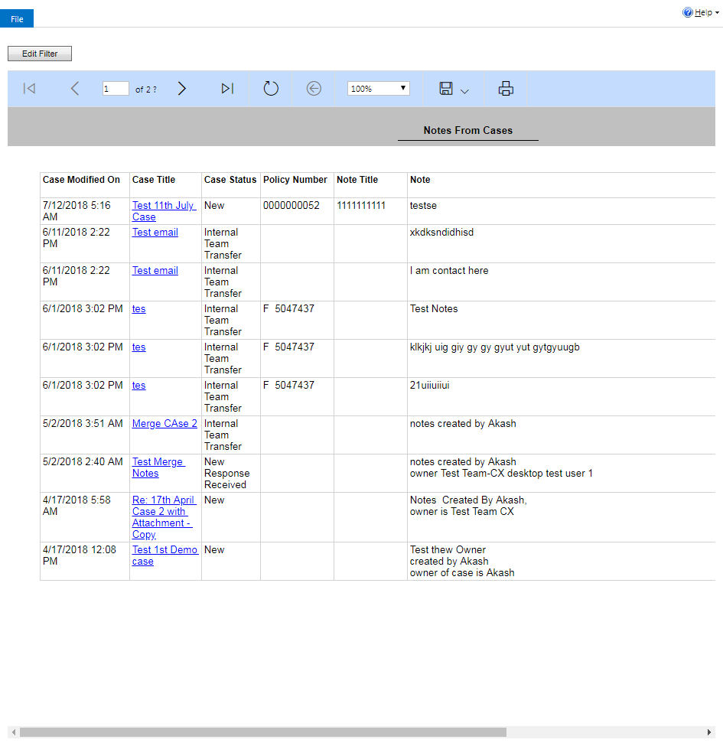

ContactManagement_Verify Contact notes _Instance44_13-Jul-2018_06-29-26_AM_VerifyingLatestNotesofanindividual.png



ContactManagement_Verify Contact notes _Instance44_13-Jul-2018_06-28-15_AM_SingleSignOn.png

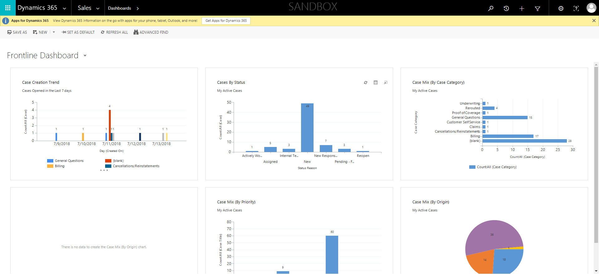

ContactManagement_Verify Contact notes _Instance44_13-Jul-2018_06-29-28_AM_VerifyingAllNotesofanindividual.png



ContactManagement_Verify Contact notes _Instance44_13-Jul-2018_06-25-30_AM_EnterTextAction.png



ContactManagement_Verify Contact notes _Instance44_13-Jul-2018_06-25-31_AM_MouseClickActiononStaleElement.png



ContactManagement_Verify Contact notes _Instance44_13-Jul-2018_06-29-21_AM_Validatingcontactentitynavigation.png

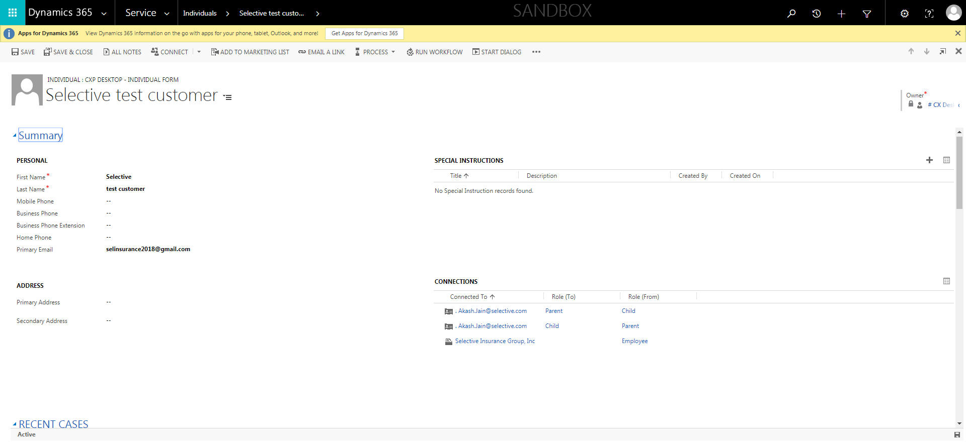

ContactManagement_Verify Contact notes _Instance44_13-Jul-2018_06-25-45_AM_SingleSignOn.png

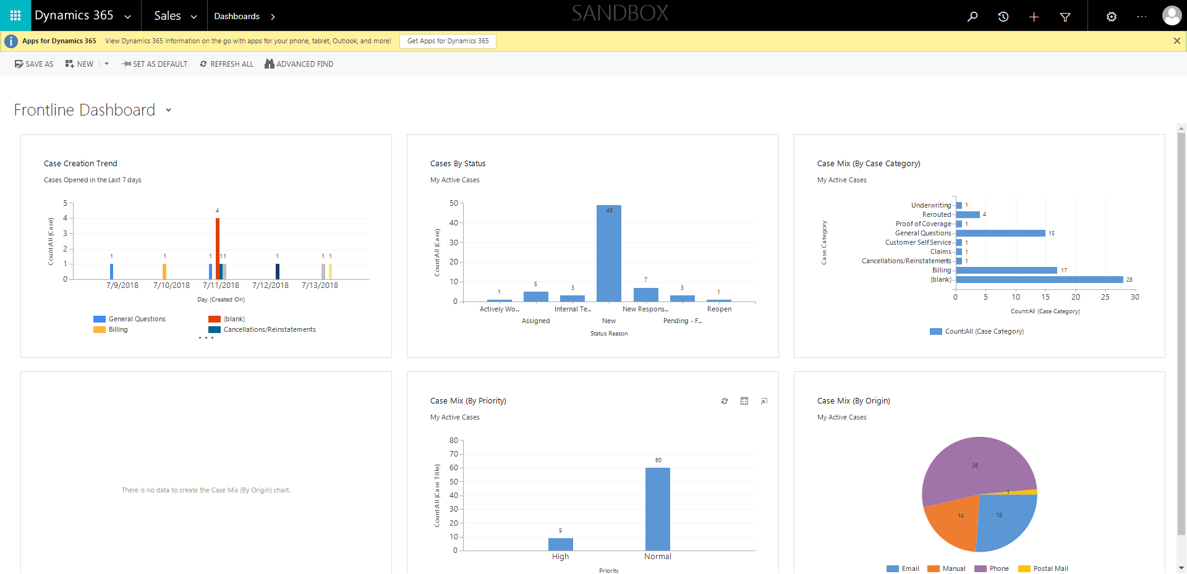

ContactManagement_Verify Contact notes _Instance44_13-Jul-2018_06-25-43_AM_SingleSignOn.png

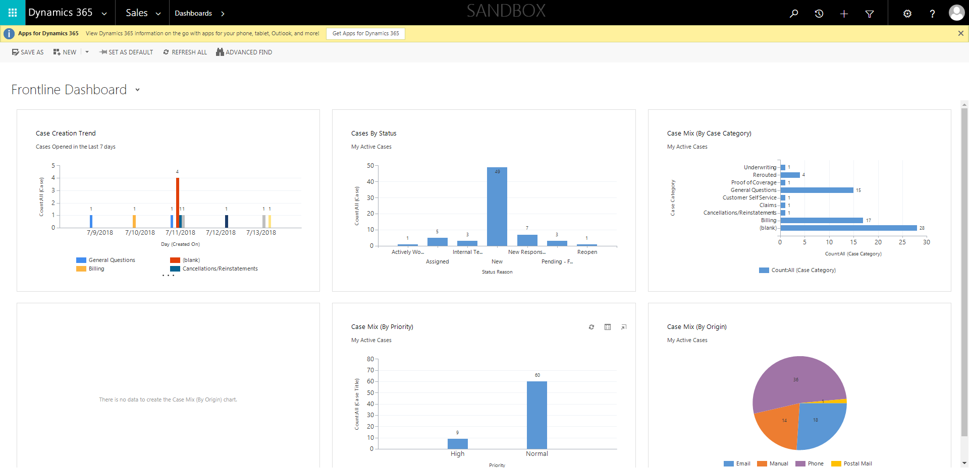

ContactManagement_Verify Contact notes _Instance44_13-Jul-2018_06-25-28_AM_MouseClickActiononStaleElement.png



ContactManagement_Verify Contact notes _Instance44_13-Jul-2018_06-26-50_AM_Validatingcontactentitynavigation.png

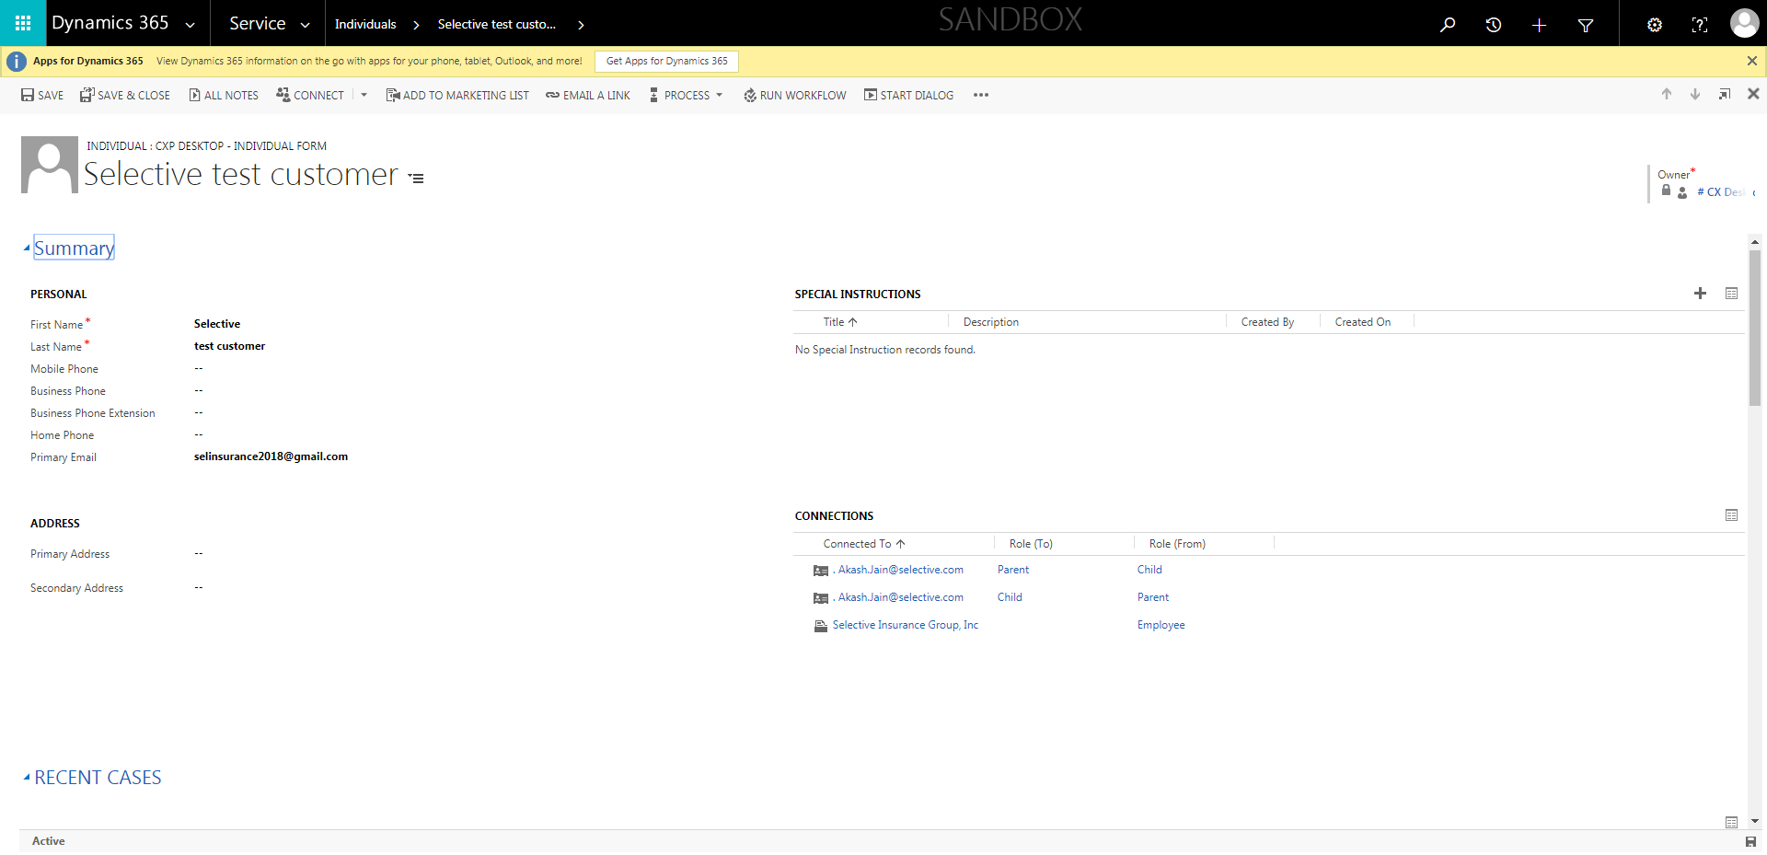

ContactManagement_Verify Contact notes _Instance44_13-Jul-2018_06-26-58_AM_VerifyingLatestNotesofanindividual.png



ContactManagement_Verify Contact notes _Instance44_13-Jul-2018_06-28-16_AM_SingleSignOn.png

